Mohamed Fathallah

Unlike other population-based methods, PSO does not resample populations to produce new ones: it has no selection of any kind. Instead, PSO maintains a single static population whose members are Tweaked in response to new discoveries about the space. The method is essentially a form of directed mutation.

Question of mine:

if i used PSO in optimizating GAN like i will make one step using PSO and another using Adams for example in optimizating GAN does this potentially works or the particles best might change and cause the PSO to move the weight toward another point other than the Adams trying to reach.

-Answers:

## Summary

Combining PSO and Adam in GAN optimization can be feasible but requires careful design to avoid conflicting updates. PSO offers population-based, gradient-free exploration, while Adam provides efficient, adaptive gradient-based exploitation [MachineLearningMastery.com](https://www.machinelearningmastery.com/a-gentle-introduction-to-particle-swarm-optimization/?utm_source=chatgpt.com)[arXiv](https://arxiv.org/abs/1412.6980?utm_source=chatgpt.com). Naively alternating full PSO and Adam steps may lead PSO’s particles to shift weights away from the trajectory that Adam was honing, potentially destabilizing training [ResearchGate](https://www.researchgate.net/publication/377398918_A_hybrid_model_of_heuristic_algorithm_and_gradient_descent_to_optimize_neural_networks?utm_source=chatgpt.com). Instead, literature suggests more integrated hybrid schemes—such as using PSO for initialization or hyperparameter tuning, and Adam for fine-tuning, or meta-optimizers that blend both update contributions dynamically—to leverage their complementary strengths without interference [MDPI](https://www.mdpi.com/1999-4893/14/6/186?utm_source=chatgpt.com)[ScienceDirect](https://www.sciencedirect.com/science/article/abs/pii/S1389041720300589?utm_source=chatgpt.com).

## Background: PSO vs. Adam

**Particle Swarm Optimization (PSO)** is a population-based metaheuristic inspired by flocking behavior, where each particle (weight vector) moves according to its own experience (pbest) and the swarm’s best (gbest) [MachineLearningMastery.com](https://www.machinelearningmastery.com/a-gentle-introduction-to-particle-swarm-optimization/?utm_source=chatgpt.com).  
**Adam** is a first-order, gradient-based optimizer that adapts learning rates using estimates of first and second moments of gradients, offering fast convergence in stochastic settings [arXiv](https://arxiv.org/abs/1412.6980?utm_source=chatgpt.com).

These differing philosophies—PSO’s global, stochastic search versus Adam’s local, gradient-driven updates—mean that their simultaneous application can either complement or conflict, depending on implementation [ResearchGate](https://www.researchgate.net/publication/377398918_A_hybrid_model_of_heuristic_algorithm_and_gradient_descent_to_optimize_neural_networks?utm_source=chatgpt.com).

## Literature on Hybrid PSO–Gradient Methods

## Literature on Hybrid PSO–Gradient Methods

* **PSO for Neural Network Training**: Early works combined PSO with other evolutionary algorithms and Adam for training ANNs, showing improved convergence rates and avoidance of local minima compared to plain backpropagation with Adam [ScienceDirect](https://www.sciencedirect.com/science/article/abs/pii/S1389041720300589?utm_source=chatgpt.com).
* **Adaptive PSO + Adam for Sequence Models**: Hybrid models merging Adaptive PSO and Adam have been applied to LSTM networks, evolving initial weights with PSO and refining with Adam, leading to better generalization in time-series tasks [SpringerLink](https://link.springer.com/article/10.1007/s00500-022-07451-8?utm_source=chatgpt.com).
* **PSO–Adam Hybrid on Object Detection**: A Dist-YOLOv3 study used PSO to optimize the initial learning rate and Adam concurrently, yielding superior loss reduction compared to using Adam alone [ResearchGate](https://www.researchgate.net/publication/383532420_Hybrid_PSO-Adam_Optimizer_Approach_for_Optimizing_Loss_Function_Reduction_in_the_Dist-YOLOv3_Algorithm?utm_source=chatgpt.com).
* **Meta-Optimizers Combining Both**: The ATMO framework adaptively weighs contributions from two optimizers (e.g., PSO and Adam) in each update, automatically balancing exploration and exploitation without manual alternation [MDPI](https://www.mdpi.com/1999-4893/14/6/186?utm_source=chatgpt.com).
* **Hybrid Heuristic + Gradient Descent**: Models integrating heuristic search steps with gradient descent in a unified loop demonstrate that alternating at a micro level (e.g., per-layer or per-batch) can avoid weight divergence if update magnitudes are scaled appropriately [ResearchGate](https://www.researchgate.net/publication/377398918_A_hybrid_model_of_heuristic_algorithm_and_gradient_descent_to_optimize_neural_networks?utm_source=chatgpt.com).

## PSO in GAN-Specific Contexts

* **Hyperparameter Tuning for GANs**: PSO has been employed to select optimal GAN hyperparameters—such as learning rates, batch size, and architectural parameters—resulting in higher-quality generations and stable training [SpringerLink](https://link.springer.com/article/10.1007/s13042-021-01440-3?utm_source=chatgpt.com).
* **PSO-Based GAN Variants**: Research on PSO-powered GANs (e.g., PGAN) uses PSO within the generator to explore latent spaces, while the discriminator remains gradient-trained, showcasing PSO’s potential to diversify generated samples [ACM Digital Library](https://dl.acm.org/doi/abs/10.4018/IJCINI.349935?utm_source=chatgpt.com).
* **PSO for Image Generation**: A face generation GAN trained with a PSO-based algorithm reported improvements in contrast and detail exploration compared to standard Adam-only training [ScienceDirect](https://www.sciencedirect.com/science/article/abs/pii/S0167739X21001126?utm_source=chatgpt.com).
* **Evolutionary Computation in Generative Models**: Surveys highlight that PSO’s gradient-free search can escape GAN mode collapse by exploring underrepresented latent regions, but emphasize hybrid setups to maintain the gradient-informed refinements of Adam [SpringerLink](https://link.springer.com/article/10.1007/s10462-024-10818-y?utm_source=chatgpt.com).

## Potential Issues & Recommendations

1. **Conflicting Directions**
   * Full PSO updates may pull weights toward different “best” points than Adam’s gradient direction, causing oscillations or divergence [ResearchGate](https://www.researchgate.net/publication/377398918_A_hybrid_model_of_heuristic_algorithm_and_gradient_descent_to_optimize_neural_networks?utm_source=chatgpt.com).
2. **Dynamic pbest Changes**
   * As pbest and gbest evolve, PSO might repeatedly shift the network away from the fine-tuned Adam trajectory, destabilizing adversarial training [ACM Digital Library](https://dl.acm.org/doi/abs/10.4018/IJCINI.349935?utm_source=chatgpt.com).
3. **Integration Strategies**
   * **Initialization & Hyperparameters**: Use PSO at the start to find good initial weights or hyperparameters, then switch to Adam for gradient-driven convergence [SpringerLink](https://link.springer.com/article/10.1007/s13042-021-01440-3?utm_source=chatgpt.com).
   * **Meta-Optimizers**: Employ frameworks like ATMO to blend PSO and Adam updates in each step, ensuring neither dominates destructively [MDPI](https://www.mdpi.com/1999-4893/14/6/186?utm_source=chatgpt.com).
   * **Layer-Wise Alternation**: Alternate PSO and Adam per layer or subnetwork, reducing cross-interference in high-dimensional weight spaces [ResearchGate](https://www.researchgate.net/publication/377398918_A_hybrid_model_of_heuristic_algorithm_and_gradient_descent_to_optimize_neural_networks?utm_source=chatgpt.com).

## Conclusion

Naively alternating PSO and Adam steps in GAN training may lead to conflicting update directions and disrupted convergence. Instead, hybrid approaches—using PSO for initialization or hyperparameter search, or employing meta-optimizers that integrate both methods’ strengths—can harness PSO’s exploration and Adam’s exploitation synergistically for stable, high-quality GAN optimization.

Papers:

<https://link.springer.com/article/10.1007/s13042-021-01440-3?utm_source=chatgpt.com>.

<https://www.sciencedirect.com/science/article/abs/pii/S1389041720300589?utm_source=chatgpt.com>.

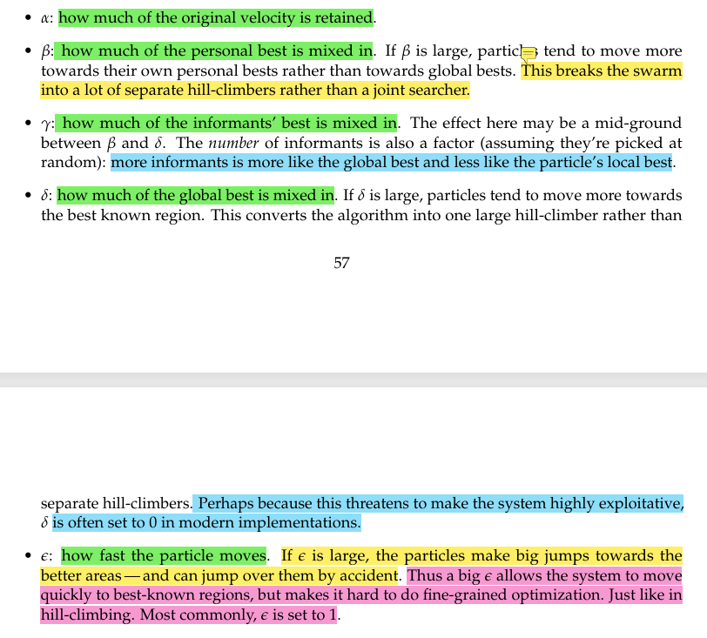

Last point is very important for my research point.